**CLIMATE CHANGE IN PAKISTAN**

What is Climate Change?

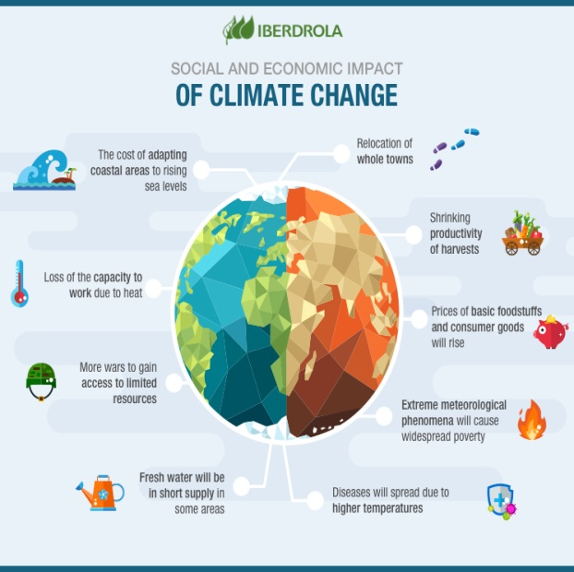Climate change characterized by a general increase in average temperatures of the Earth, which modifies the weather balances and ecosystems for a long time. It is directly linked to the increase of greenhouse gases in our atmosphere, worsening the greenhouse effect.

* 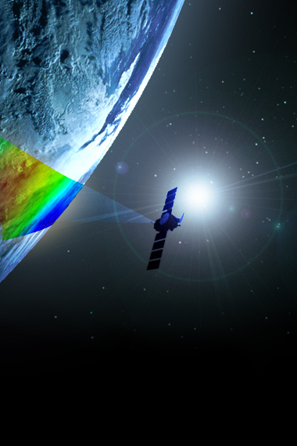**According to the BBC Climate Asia report**, the majority of the Pakistani people surveyed claimed that climate change has heavily impacted their lives in the form of floods and droughts, and most importantly has affected the availability of resources such as energy and water. 53% of Pakistanis felt that their lives had become worse off than they were five years ago. Although the effects of climate change are evident, the survey found that the majority of the people were unaware of the meaning of climate change, and "ascribed changes in climate and extreme weather events to the will of God."
* **According to the Pakistan Economic Survey of 2014-15,** the "increase in frequency and intensity of extreme weather events coupled with erratic monsoon rains causing frequent and intense floods and droughts" are the most prominent problems Pakistan will face due to climate change. The survey concluded that the change in weather patterns has destroyed infrastructures, has taken many lives and has had devastating impacts on the agriculture sector, which has in turn has affected Pakistan's economy.

Causes Of Climate Change

* 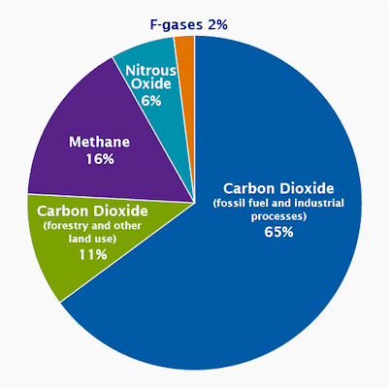**Greenhouse Gas**

The most common and most talked about greenhouse gases is CO2 or carbon dioxide. In fact, because it is so common, scientists use it as the benchmark or measure of things that warm the atmosphere. Fossil fuel and related uses of coal and petroleum are the most important sources of GHGs and black carbon (power generation, industry, transportation, buildings).

* **Air Pollution**

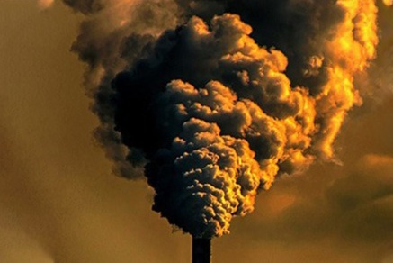These two are the most prevalent types of air pollution. Smog, or “ground-level ozone,” as it is more wonkily called, occurs when emissions from combusting fossil fuels react with sunlight. Soot, or “particulate matter,” is made up of tiny particles of chemicals, soil, smoke, dust, or allergens, in the form of gas or solids, that are carried in the air. The EPA’s “Plain English Guide to the Clean Air Act” states, “In many parts of the United States, pollution has reduced the distance and clarity of what we see by 70 percent.

* 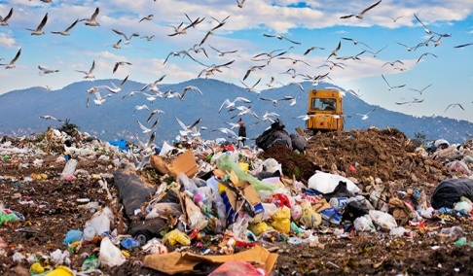**Waste**

When organic waste decomposes, carbon dioxide and methane gas is created. Methane is created when there is no air present while carbon dioxide is the natural product when anything rots in air. Both carbon dioxide and methane are greenhouse gases, which contribute to global warming and climate change

* 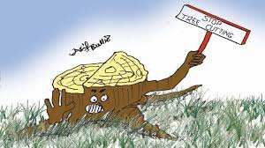**Deforestation**

Deforestation is the second leading cause of global warming and produces about 24% of global greenhouse gas emissions. Scientist say that deforestation in tropical rainforests adds more carbon dioxide to the atmosphere than the sum total of all the cars and trucks on the world's roads.

* **Technology**

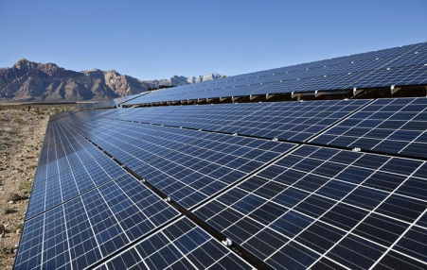We live in the most advanced time in technological innovation. Unfortunately though, early technological advancements were hardly environmentally conscious. Coal was first used in the 1880s, but on a minor scale. However, by 1961, it had become the primary fossil fuel used to generate electricity, per the U.S. Department of Energy

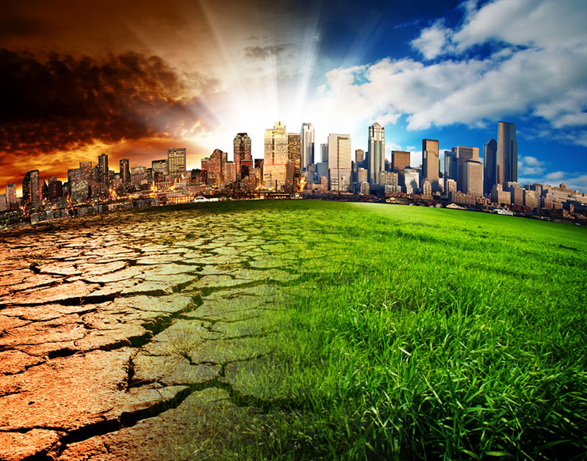Effects Of Climate Change

* **Rise in Temperature**

In 2018, Nawabshah saw temperatures hit 50.2 degrees Celsius — the hottest day of April ever recorded anywhere in history. Last week, Jacobabad hit 51°C.

* **Health Effects**

The last year, more than 60 people have died from the heat in Karachi.

* **Glacier Melt and Floods**

The **Tibetan Plateau** contains the world's third-largest store of ice. Qin Dahe, the former head of the China Meteorological Administration, said the recent fast pace of melting and warmer temperatures will be good for agriculture and tourism in the short term, but issued a strong warning:

"Temperatures are rising four times faster than elsewhere in China, and the Tibetan glaciers are retreating at a higher speed than in any other part of the world... In the short term, this will cause lakes to expand and bring floods and mudflows.. In the long run, the glaciers are vital lifelines of the Indus River. Once they vanish, water supplies in Pakistan will be in peril."

"**There is insufficient data to say what will happen to the Indus,"** says David Grey, the World Bank's senior water advisor in South Asia. "But we all have very nasty fears that the flows of the Indus could be severely, severely affected by glacier melt as a consequence of climate change," and reduced by perhaps as much as 50 percent. "Now what does that mean to a population that lives in a desert [where], without the river, there would be no life? I don't know the answer to that question," he says. "But we need to be concerned about that. Deeply, deeply concerned."

U.S. diplomat Richard Holbrooke said, shortly before his death in 2010, that he believed that falling water levels in the Indus River "could very well precipitate World War III."

* **Impacts on Aquatic Life**

Marine species affected by climate change include plankton - which forms the basis of marine food chains - corals, fish, polar bears, walruses, seals, sea lions, penguins, and seabirds.

The Intergovernmental Panel on Climate Change predicts a further rise of between 1.4°C and 5.8°C by the end of the century. Climate change could therefore well be the knock-out punch for many species which are already under stress from overfishing and habitat loss.

Solutions Of Climate Change

1. **Avoid Transportation**

As the transport systems in our major cities come under pressure, some commuters and communities are experiencing negative effects such as high transport costs and travel times, congestion, overcrowding, noise, air pollution, and reduced physical activity.

1. **Avoid Technology**

how much electricity is being used overnight around the earth. Climate change has worsened at the hands of human activity for centuries, and many scientific efforts have been made since the first political acknowledgment. In order to avoid the ongoing and potential impacts of climate change, mitigation technologies have been developed in order to adapt to the issue, each invention belonging to one of four specific groups of effort. These groups include energy efficiency improvements, renewable energy (RE), nuclear power/energy (NE), and carbon capture storage (CCS).

1. **Stop Cutting Down Trees**

Every year, 33 million acres of forests are cut down. Timber harvesting in the tropics alone contributes 1.5 billion metric tons of carbon to the atmosphere. That represents 20 percent of human-made greenhouse gas emissions and a source that could be avoided relatively easily.

1. **Creating knowledge**

Education plays a vital role in combating climate change and is key to understanding how the human-made climate crisis is affecting the planet. Our knowledge of the climate crisis is based on solid science, research, data that scientists across the world rigorously dissect and analyze

1. **Waste Management**

The reduction and recycling of solid waste can help address global climate change. The distribution, application and manufacture of products, as well as management of the resulting waste, all result in greenhouse gas emissions.

Conclusion

* [global warming](https://en.wikipedia.org/wiki/Global_warming) could cause Earth's surface temperature to exceed historical values as early as 2047
* which the United Nations' [IPCC](https://en.wikipedia.org/wiki/Intergovernmental_Panel_on_Climate_Change) designated as the upper limit to avoid "dangerous" levels, by 2036
* **U.S. National Academy of Sciences**

"Scientists have known for some time, from multiple lines of evidence, that humans are changing Earth’s climate, primarily through greenhouse gas emissions."